Source: <https://www.greenpeace.org/philippines/press/61036/malabon-resolution-paves-the-way-sustainable-mobility-week-carless-day/>

**Malabon resolution paves the way for sustainable mobility**

September 16, 2023

 “Mobility is not just about ’traffic and cars’ but is everyone’s agenda: sustainable mobility benefits everyone’s well-being, as well as the environment and climate.”

Sept. 16-22 is Malabon Mobility Week – resolution

Sep 22 as Malabon Carless Day

* Propose sustainable alternatives to progress towards a sustainable and strategic transportation system
* There’s an overdependence on cars

Source: <https://cityofmalabonuniversity.edu.ph/2023/04/05/city-of-malabon-universitys-strategic-planning-2024-session-3-collaborative-efforts-on-plans-and-programs-for-the-year-2024/>

**City of Malabon University’s Strategic Planning 2024 Session 3: Collaborative Efforts on Plans and Programs for the Year 2024**

April 5, 2023

* Ensure that all offices are aligned with each other in terms of their respective plans and programs for the year 2024
* Emphasized the need for collaboration and coordination among offices to achieve the goals set for 2024

Source: <https://www.scribd.com/doc/249719538/Malabon-CLUP>

MALABON CITY: Comprehensive Land Use Plan 2014-2020

* Special regard to **LenLen Oreta**
* Centered on Malabons vision to be a model city for resiliency in the Philippines
* MMDA assisted in data gathering to guide the **transportation plan, provide basemaps and literatures for local and national dev’t**
* UP SURP coordinated for planning expertise and knowledge in formulating a land use plan
* (would really want to get a hold of a copy for this paper)

Source: Malabon City Executive Summary 2021

Other Programs and Projects

EDUCATION

* Project RIDE (Response In Delivery of Education)
  + Make sure that learners promptly receive and return their learning materials during lockdown periods
* Project SHARE
  + Strategy to strengthen home facilitator’s skills in facilitating distance learning and accelerating ICT skills for retooling and readiness to achieve excellence in education amidst the pandemic

HEALTH

* Build Super Health Centers
* Established eight accredited Temporary Treatment Management Facilities

SOCIAL WELFARE SERVICES

* Constructed Malabonian Sports Complex
* Financial assistance tio 4000 marginalized families

PEACE AND ORDER

* Conducted 205 operations and 99 buy bust operations

HOUSING

* Marangal Village People’s Plan Phase I (a 3-storey housing buildings with a total of 282 units) at Brgy. Longos was benefitted to informal settler families along the waterways
* Marangal Village Phase II is on-going

EMPLOYMENT

* Financial assistance projects to active job/livelihood seekers
* Balik Trabaho Patungong Asenso Program + temporary employment

LIVELIHOOD

* Pangkabuhayan at Ginhawa Program (PPG), Diskwento Caravan, DTI E-Commerce Program, cooperative visitation, mandatory trainings and Cooperative Month Celebration

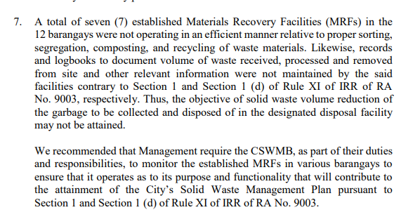

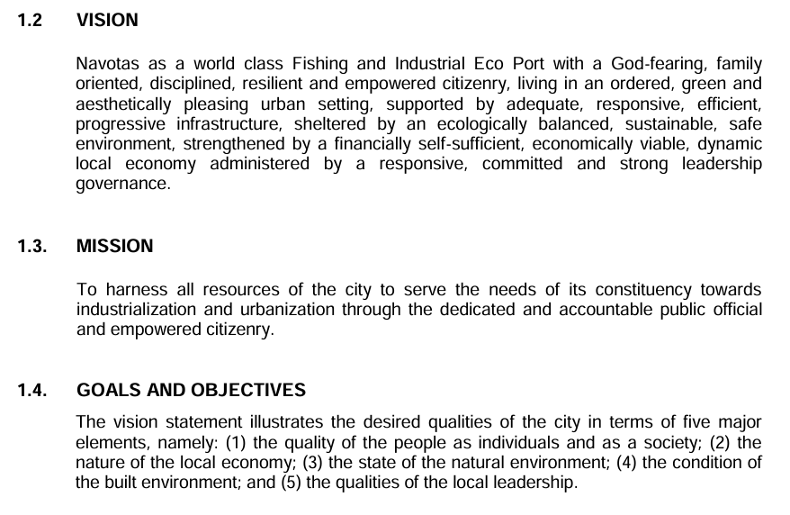Source: Comprehensive Land Use Plan 2016-2025 (Navotas)

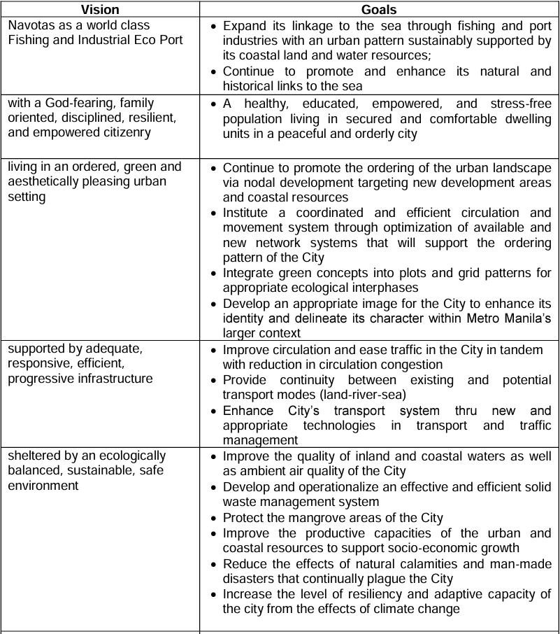

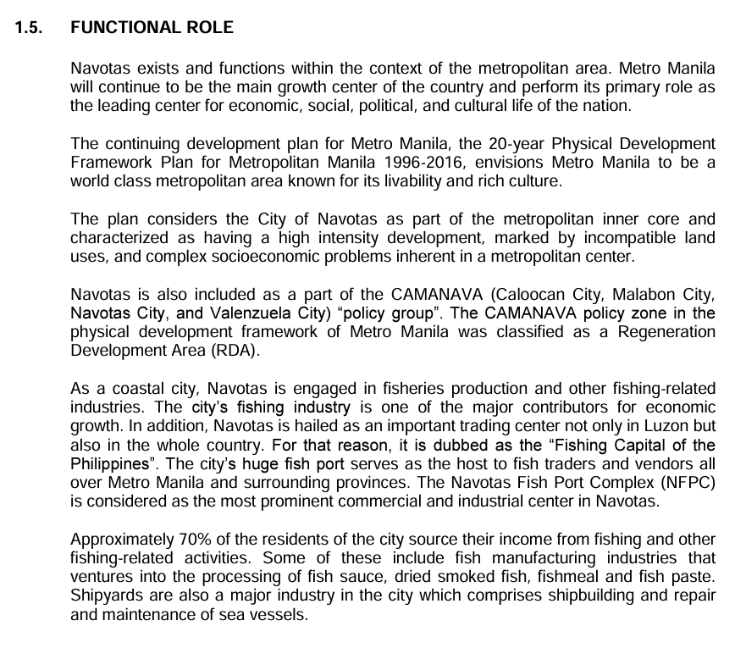

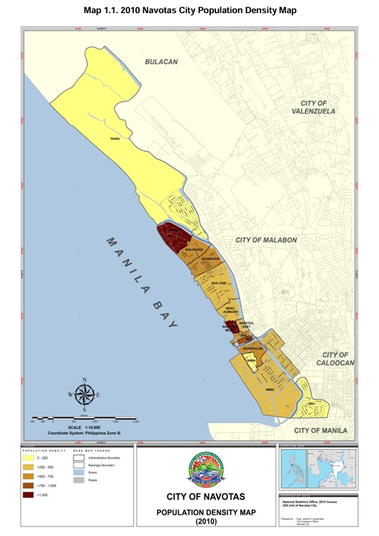

Might as well consider to have a population density map for Malabon

The next few pages were demographics per barangay and age group + gender.

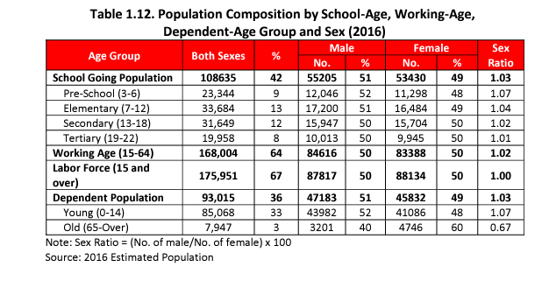

Source: Assessment of cascading effects of typhoons on water and sanitation services: A case study of informal settlements in Malabon, Philippines

Source: Social and Economic Impacts of Flooding and Land Subsidence in KAMANAVA, Metro Manila

Authors: Karen Ann Jago-on, Shinki Kaneko, Satoru Komatsu

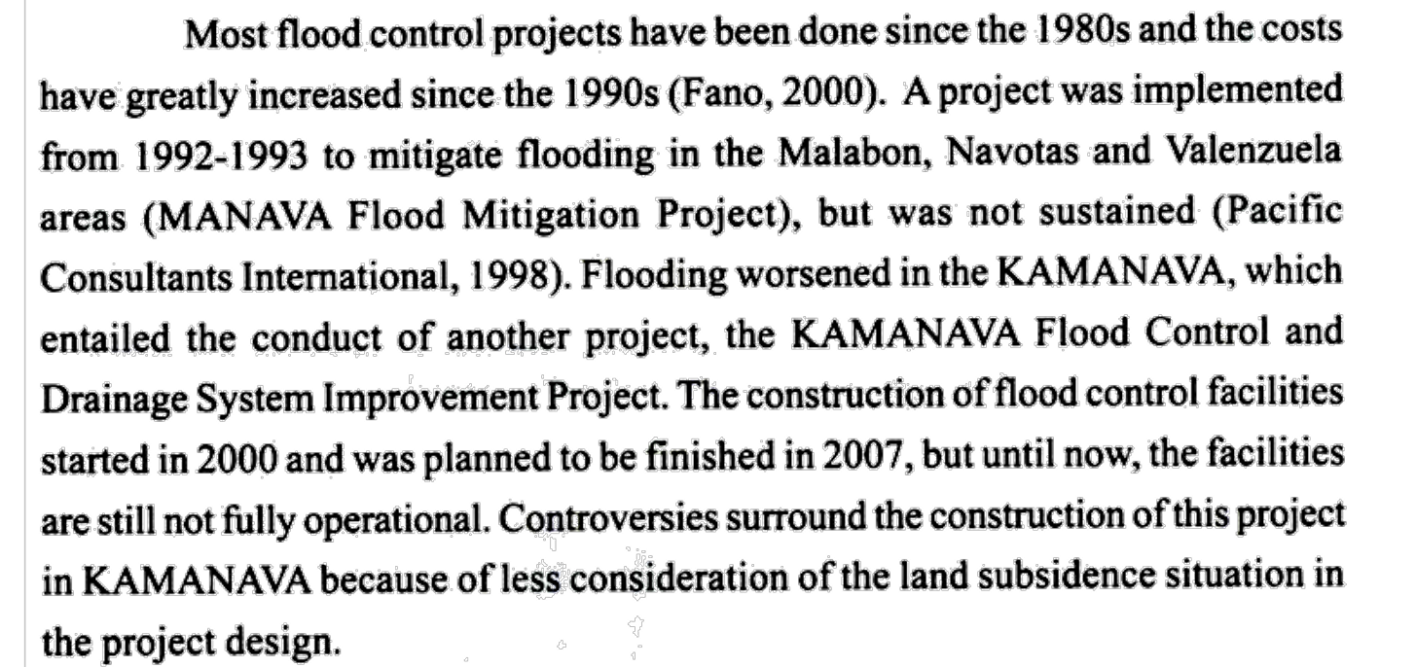

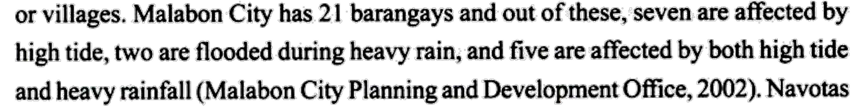

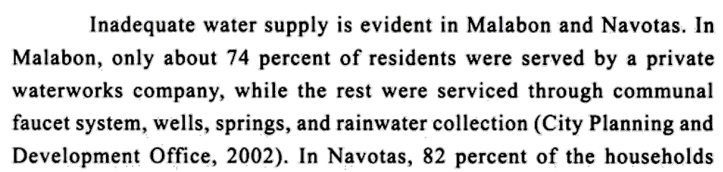

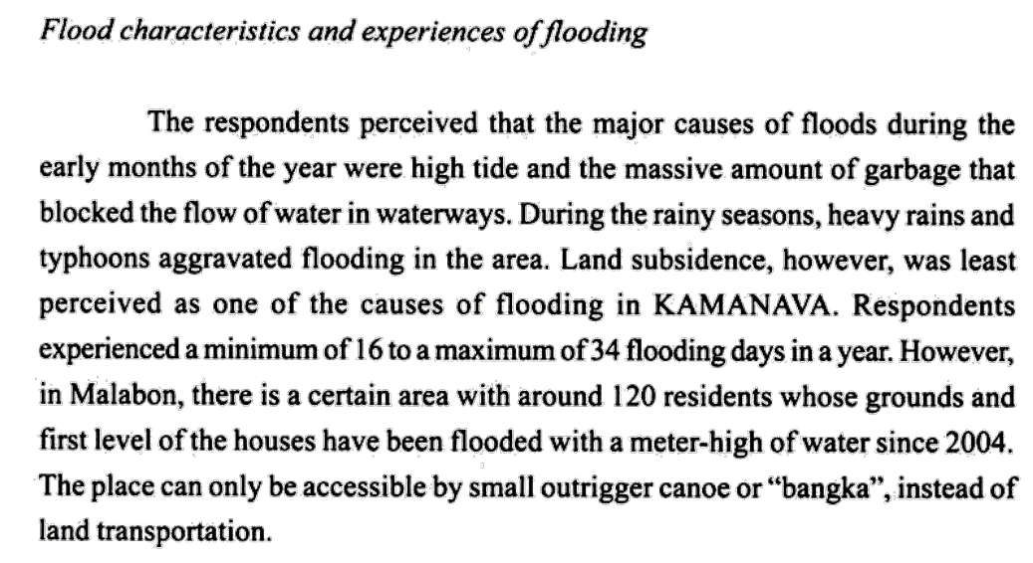

Typically July and August yung may pinakamataas na flooding rate.

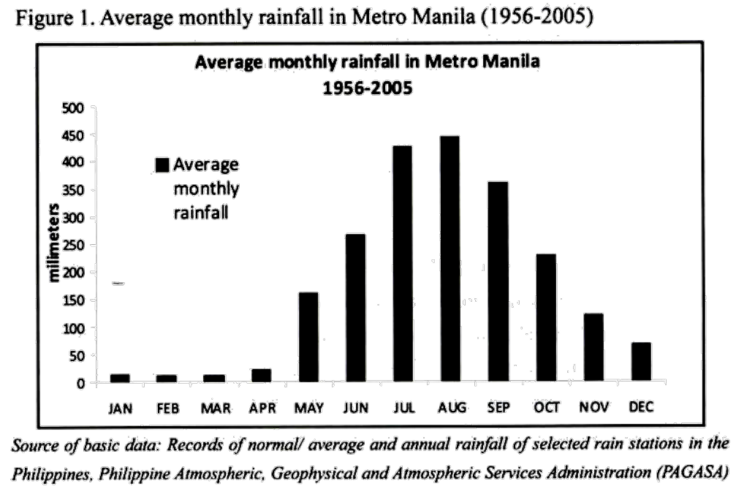

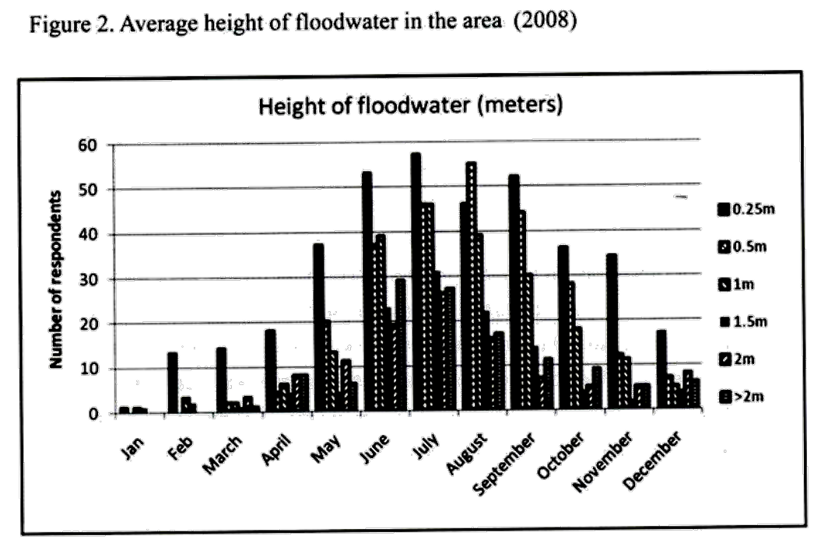

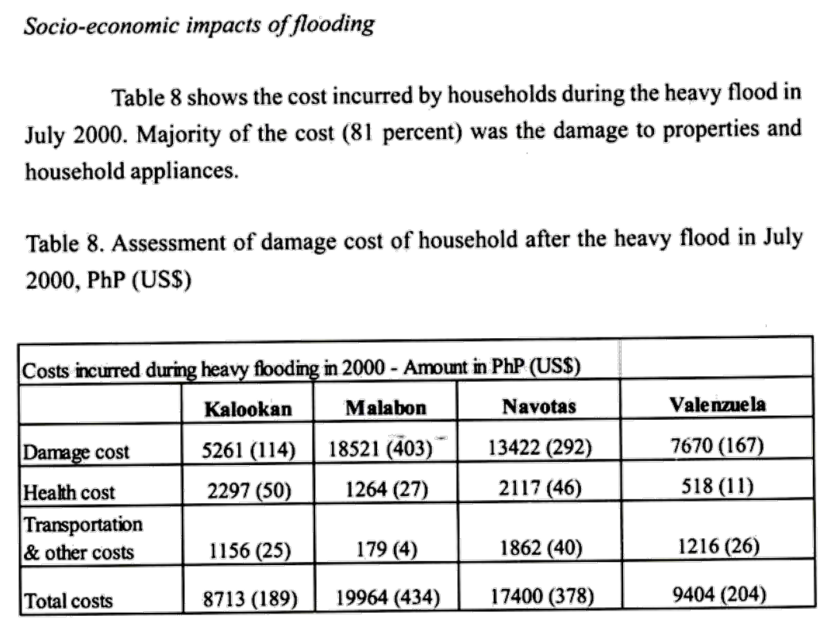

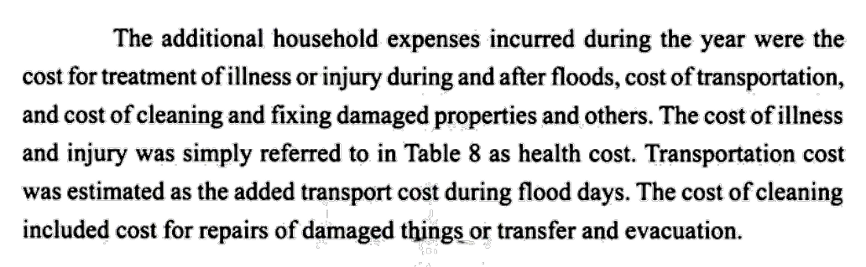

Health impacts:

Common diseases are colds, pneumonia, diarrhea, dengue fever, skin diseases, and leptospirosis.

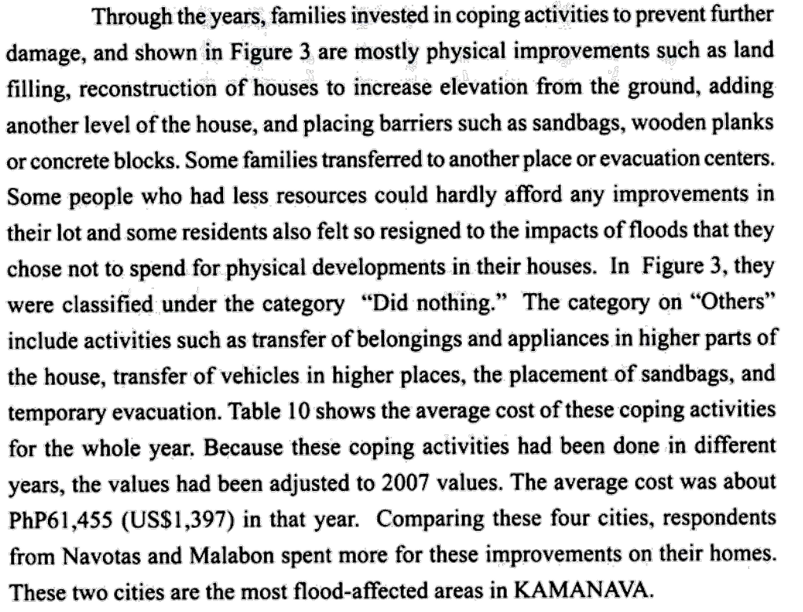

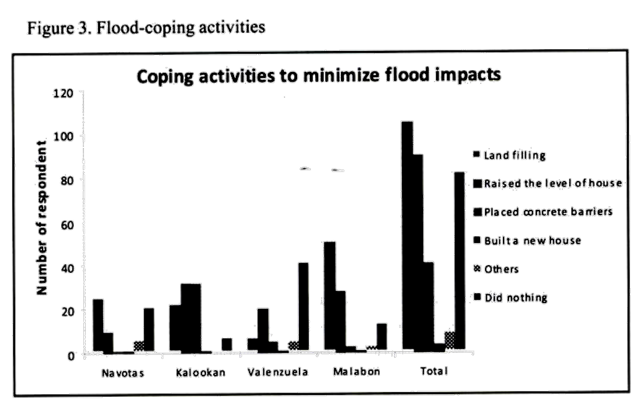

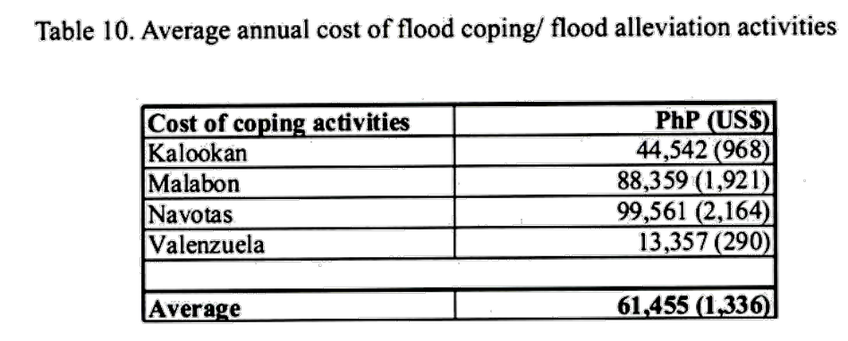

Similar coping mechanisms are done by companies and businesses.

